**A**

**Synopsis**

**on**

**BEAT STAR**

**Submitted by**

**Group. No.**

**Priya Garg(Team Leader) -2100290140107**

**Prashant Sharma -2100290140105**

**Dhaval Krishna-2100290140059**

**Shivam Agrawal -2100290140126**



**- Submitted to**

**Project Supervisor**

Miss Divya Singhal

**Department of Computer Applications,**

**KIET Group of Institutions,**

**Delhi-NCR, Ghaziabad**

**September 2022**

**ABSTRACT**

* It is a Music Web Application which works on the technology react framework and backend technology spring boot. It contains various types of music such as :- Jazz Music, Rhythm and Blues Music,Rock and Roll Music, Rock Music etc. we are giving a mic facility and audio recommendation for users Online music portal as described above can head to error free, secure reliable and fast management system. It can also assist the user to concentrate on their other activities rather to concentrate on the record keeping Thus it will help to organization in better utilization of resources The organization can maintain computerized records without redundant entries that means that one need not be distracted by information that is not relevant while being able to reach the information. its databases connect on online server. it’s a single page web Application which is responsive.

**Table of Contents**

1. Introduction
2. Technologies / Software Requirements
3. Hardware requirement / Hardware Used
4. Modules Description
5. Gantt Chart (In terms of weeks)
6. Conclusion
7. How to serve the society (If applicable)

**Introduction:**



The “Online Music Portal “ has been developed to override the problems prevailing in the practicing manual system. This software is supported to eliminate and in some cases reduce the hardship faced by this existing system . Moreover this system is designed for the particular need to carry out operations in a smooth and effective manner.

The application is reduced as much as possible to avoid errors while entering the data. It is user friendly . Every organization , whether big or small has challenges to overcome and managing the information of Album , Music , Track , Customer , Album Type. Every online music portal has different music needs therefore we design exclusive employees management systems that are adapted to your managerial requirements.

The purpose of online music portal is to automate the existing manual system by the help of computerized equipments and full- fledged computer software , fulfilling their requirements so that their valuable data/ information can be stored for a longer period with easy accessing and manipulating of the same. The required software and hardware are easily available and easy to work with.

The aim is to automate its existing manual system by the help of computerized equipments and full-fledged computer software , fulfilling their requirements, so that their valuable data.

**Technologies / Software Requirements:**

Technologies required for developing the application are for

**Frontend:**

React framework.

**Backend:**

Spring Boot:

Code Editor:

Microsoft Visual Studio code

* **Hardware Requirements:**

Name of Component : Specification

Processor : core i5

RAM : Minimum 4GB, recommended 8 GB

SSD : 512 GB

Monitor: 15” color monitor

Keyboard : 122 keys

Disk Space: Minimum 10 GB of free disk space

**Modules Description**

* **Music Management Module:**

The music management project is a self-directed module that allows students to showcase the skills and abilities developed during the previous years of study. The module spans the whole academic year and provides the opportunity to investigate an area that is of particular research interest to the student**.**

Music Management Fundamentals lays advanced theoretical foundations for the practical work you will learn to do later in the Programme. Why is the international music business organised the way it is? What forces – technological, economic, political and creative – have driven industry developments in the past, and where are they likely to drive it in future? How do audiences consume music? How are consumption patterns changing? What motivates musicians to make music; and why do audiences want to listen? These questions matter because they define the context in which music managers have to operate.

* **Customer Module:** The Customer module is where you go to add and edit information about your customers. You can enter and edit their physical address, contact information, salesperson, groups, default carrier, and much more. It’s a useful module to visit whenever you need to drill into a customer’s history and check other information about them.
* **Album Management Module**: Used for managing the information and details of the album. where the customer can manage his songs. And enjoy the music and play songs repeateadly.
* **Login Module**: This module ensures that only authorized users can acess to the dataase. An authorized user is a user that has account on system and manage all the login details of the users.

**Users Module:** The user module allows users to register, log in, and log out. Users benefit from being able to sign on because this associates content they create with their account and allows various permissions to be set for their roles. The user module supports user roles, which can be set up with fine-grained permissions allowing each role to do only what the administrator permits. and Used for managing the users of the system.

**Gantt Chart (In terms of weeks)**

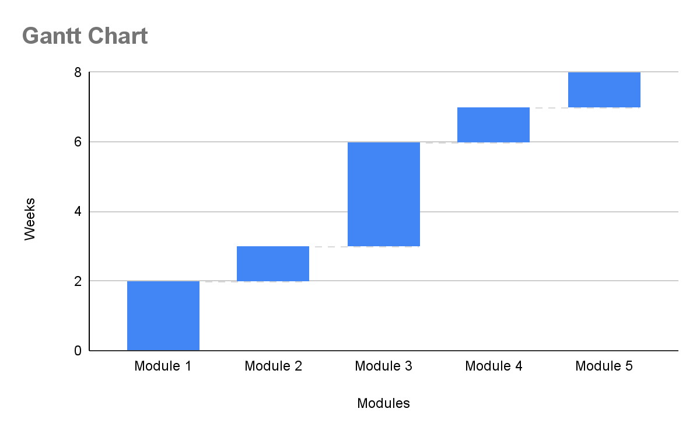

**Conclusion:**

Through the development of music player on Android platform, we get a clear understanding of

overall process of the system. The core part of the music player is mainly composed of main interface,

file browsing and song listing, Grasping the development of the music player has had the preliminary

scale small features.

Music player system realized the basic function of player: play, pause, rewind and fast forward a volume adjustment is performed through the Android System Itself, play mode, song search seekbar.

This development implicated the popular mobile terminal development technology. This is the

combination management of Java language in the open source mobile platform based on Linux system

configuration file. The system realized the music player programming.

This design of music player based on Android system requires elaborate design of the music player

framework, by adopting react js+ Java language as technical support of this system,

with and combination of Latest Android SDK version lead to the

comprehensive and smoothly design and development of the mobile terminal

**How to serve the society:**

* It can help in the healing process, dismantling walls and boundaries, reconciliation, and education. Around the world, music is being used as a vehicle for social change and bringing communities together.
* At the core of our everyday experience with music, we use it to relax, express ourselves, come to terms with our emotions, and generally improve our well-being. It has evolved into a tool for healing and self-expression, often dictating how we, as individuals, take steps to impact society.